Milestone 1

A1.
Data Repetition: User, movie, and theatre details are repeated for every booking.
Update Problem: If user email or theatre location changes, it must be updated in many rows.
Insertion Problem: Movie or theatre details cannot be added unless a booking exists.
Deletion Problem: Deleting a booking may also remove important movie or theatre information.
seat numbers is not atomic: One field may store multiple seat values like a,b,c which breaks 1NF.
Too much data in one table: User, movie, theatre, booking, and payment details are all mixed together.
total price may become inconsistent: It is a calculated value and may become incorrect if prices change.
No proper relationships: Separate tables and foreign key relationships are missing.

A2.
1.Users
user_id (Primary Key)
user_name
user_email

2.Movies
movie_id (Primary Key)
movie_name

3.Theaters
theatre_id (Primary Key)
theatre_name
theatre_location

4.Shows
show_id (Primary Key)
movie_id (Foreign Key)
theatre_id (Foreign Key)
show_time

5.Bookings
booking_id (Primary Key)
user_id (Foreign Key)
show_id (Foreign Key)
total_price

6.Seats
seat_id (Primary Key)
booking_id (Foreign Key)
seat_number

7.Payment
payment_id (Primary Key)
booking_id (Foreign Key)
payment_status

CREATE TABLE Users (
user_id INTEGER PRIMARY KEY,
user_name VARCHAR(100),
user_email VARCHAR(100)
);

CREATE TABLE Movies (
movie_id INTEGER PRIMARY KEY,
movie_name VARCHAR(100)
);

CREATE TABLE Theatres (
theatre_id INTEGER PRIMARY KEY,
theatre_name VARCHAR(100),
theatre_location VARCHAR(100)
);

CREATE TABLE Shows (
show_id INTEGER PRIMARY KEY,
movie_id INTEGER,
theatre_id INTEGER,
show_time DATETIME,
FOREIGN KEY (movie_id) REFERENCES Movies(movie_id),
FOREIGN KEY (theatre_id) REFERENCES Theatres(theatre_id)
);

CREATE TABLE Bookings (
booking_id INTEGER PRIMARY KEY,
user_id INTEGER,
show_id INTEGER,
total_price DECIMAL(10,2),
FOREIGN KEY (user_id) REFERENCES Users(user_id),
FOREIGN KEY (show_id) REFERENCES Shows(show_id)
);

CREATE TABLE Seats (
seat_id INTEGER PRIMARY KEY,
booking_id INTEGER,
seat_number VARCHAR(10),
FOREIGN KEY (booking_id) REFERENCES Bookings(booking_id)
);

CREATE TABLE Payments (
payment_id INTEGER PRIMARY KEY,
booking_id INTEGER,
payment_status VARCHAR(20),
FOREIGN KEY (booking_id) REFERENCES Bookings(booking_id)
);

A3.
A user can book tickets many times.
One booking is made by only one user.
The same movie can run in different theatres and at different times.
One theatre can show many movies.
Every show happens at a fixed time in one theatre.
A booking can include more than one seat.
Seat details are stored separately instead of storing many seat numbers in one column.
One booking has one payment detail.
Payment status can be Paid, Pending, or Failed.
Total price means the full amount for all seats booked together.

B1.

Can a theatre have many screens?
Can the same movie run in different theatres?
Will ticket price be different for each show?
Can one booking have many seats?
Can users cancel tickets?
What seat types are available like Regular or VIP?
Can a movie have many languages?

B2.
1.Users
user_id (Primary Key)
user_name
user_email
phone_number

2.Theatres
theatre_id (Primary Key)
theatre_name
city

3.Screens
screen_id (Primary Key)
theatre_id (Foreign Key)
screen_name

4.Movies
movie_id (Primary Key)
movie_name
genre
language
duration

5.Shows
show_id (Primary Key)
movie_id (Foreign Key)
screen_id (Foreign Key)
show_date
show_time
price

6.Seat_Types
seat_type_id (Primary Key)
seat_type_name

7.Seats
seat_id (Primary Key)
screen_id (Foreign Key)
seat_number
seat_type_id (Foreign Key)

8.Bookings
booking_id (Primary Key)
user_id (Foreign Key)
show_id (Foreign Key)
booking_date
total_price
payment_status

9.Booking Seats
booking_seat_id (Primary Key)
booking_id (Foreign Key)
seat_id (Foreign Key)

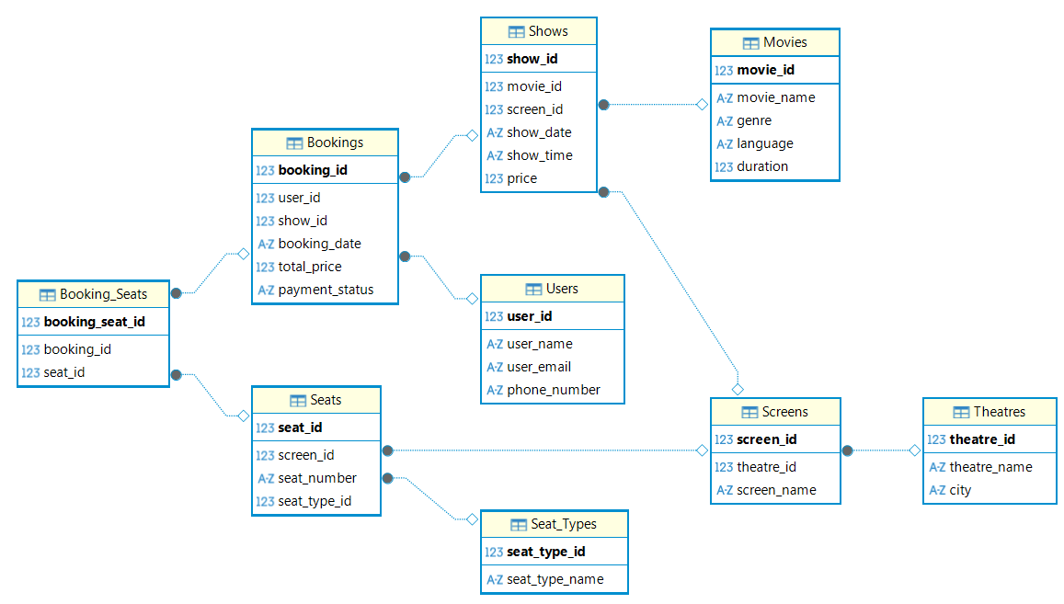

B3.

The schema is normalized because separate tables are used for users, movies, theatres, shows, seats, and bookings.
Repeated data is reduced and primary key and foreign key relationships are maintained properly.
The schema follows 3NF and helps avoid redundancy and inconsistency.

Changes Made
Removed user_id from Bookings table.
Added a new table Booking_Users
booking_user_id (PK)
booking_id (FK)
user_id (FK)
Updated Booking_Seats table
booking_seat_id (PK)
booking_id (FK)
user_id (FK)
seat_id (FK)
This change allows multiple users in one booking and connects each user to their booked seats.

Section-C
1.
SELECT u.user_name,m.movie_name,t.theatre_name,s.show_time,se.seat_number,b.booking_date
FROM Bookings b
JOIN Users u ON b.user_id = u.user_id
JOIN Shows s ON b.show_id = s.show_id
JOIN Movies m ON s.movie_id = m.movie_id
JOIN Screens sc ON s.screen_id = sc.screen_id
JOIN Theatres t ON sc.theatre_id = t.theatre_id
JOIN Booking_Seats bs ON b.booking_id = bs.booking_id
JOIN Seats se ON bs.seat_id = se.seat_id
WHERE u.user_id = 1
AND b.booking_date BETWEEN '2026-04-01' AND '2026-04-30';
2.
SELECT
m.movie_name,
COUNT(b.booking_id) AS total_bookings
FROM Bookings b
JOIN Shows s ON b.show_id = s.show_id
JOIN Movies m ON s.movie_id = m.movie_id
GROUP BY m.movie_name
ORDER BY total_bookings DESC
LIMIT 1;

3.
SELECT m.movie_name,s.show_time,
COUNT(bs.seat_id) AS booked_seats,
COUNT(se.seat_id) - COUNT(bs.seat_id) AS available_seats
FROM Shows s
JOIN Movies m ON s.movie_id = m.movie_id
JOIN Screens sc ON s.screen_id = sc.screen_id
JOIN Theatres t ON sc.theatre_id = t.theatre_id
JOIN Seats se ON sc.screen_id = se.screen_id
LEFT JOIN Booking_Seats bs ON se.seat_id = bs.seat_id
WHERE t.theatre_name = 'PVR'
AND s.show_date = '2026-04-29'
GROUP BY m.movie_name, s.show_time;
4.
START TRANSACTION;

SELECT *
FROM Seats
WHERE seat_id = 101
AND seat_id NOT IN (
SELECT seat_id FROM Booking_Seats
);

INSERT INTO Bookings
VALUES (1, 1, 1, '2026-04-29', 500, 'Paid');

INSERT INTO Booking_Seats
VALUES (1, 1, 101);

COMMIT;

ROLLBACK;

